Appium Setup Steps (Android)
Changes have been made in this line as a new user – pals123
made in this line as a new user – pals123567

- Download and install Appium Server from below URL: https://bitbucket.org/appium/appium.app/downloads/
- Make sure you have Android SDK installed in your machine. Open SDK Manager from Android SDK folder and download the latest updates.

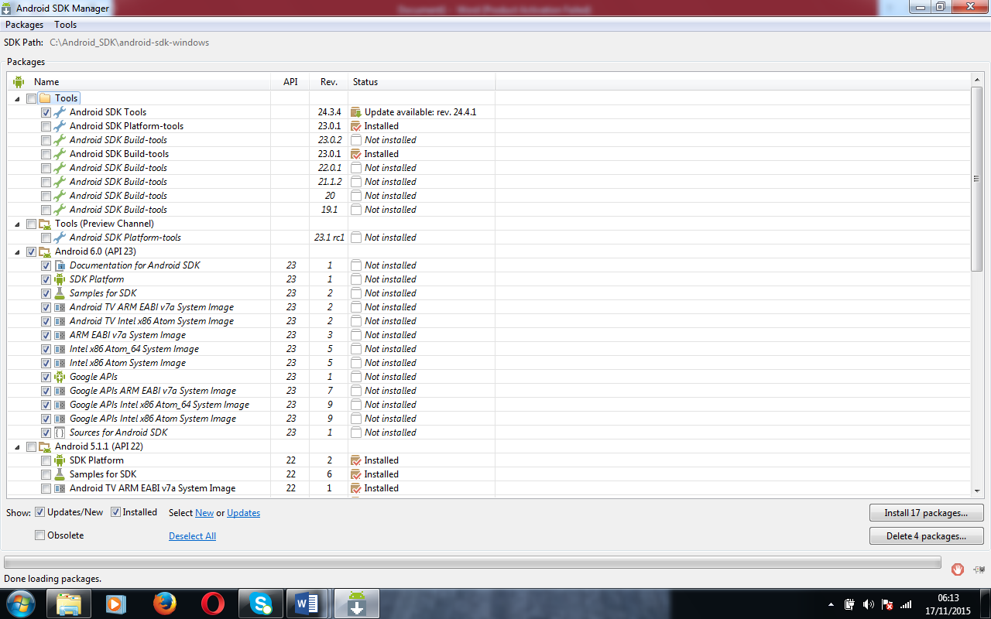

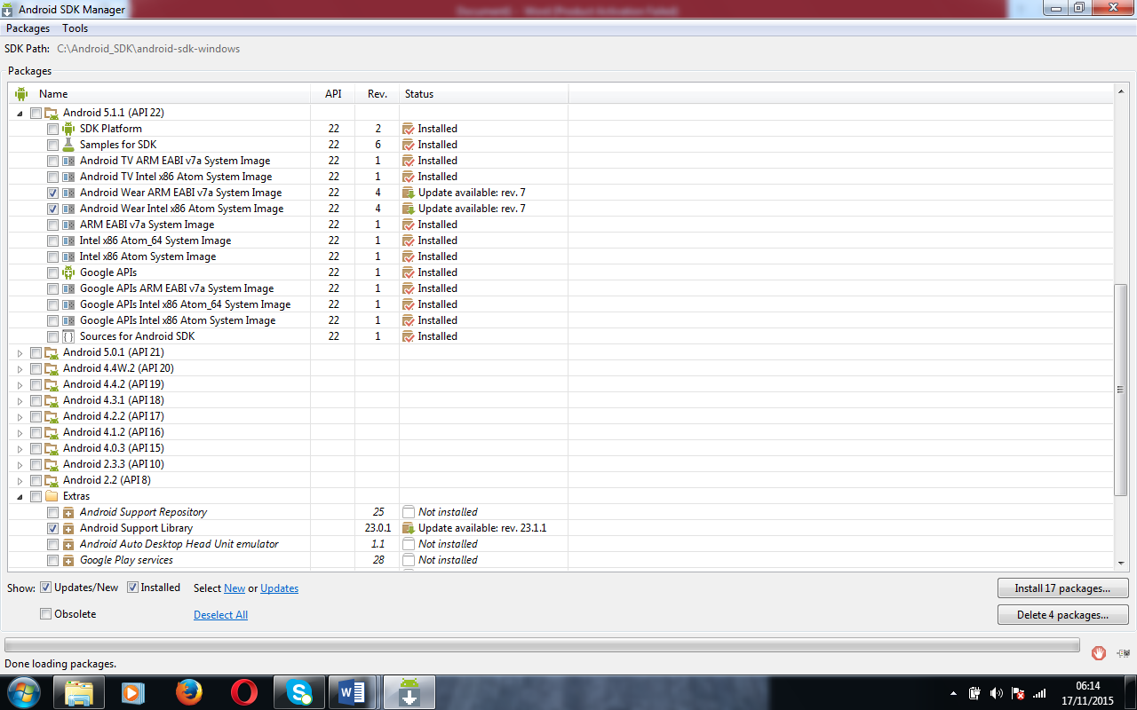
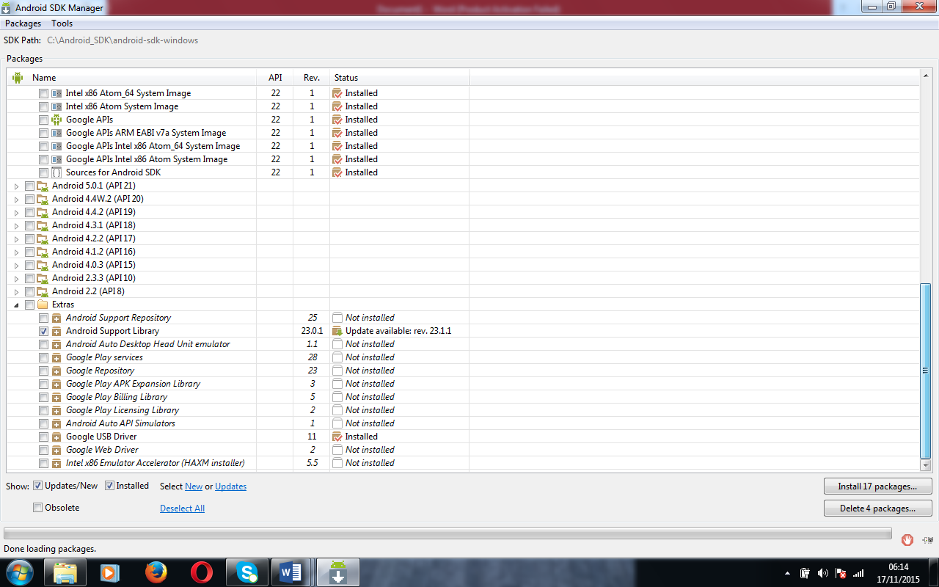

- Set the ANDROID_HOME variable in the System Environment Variable section.
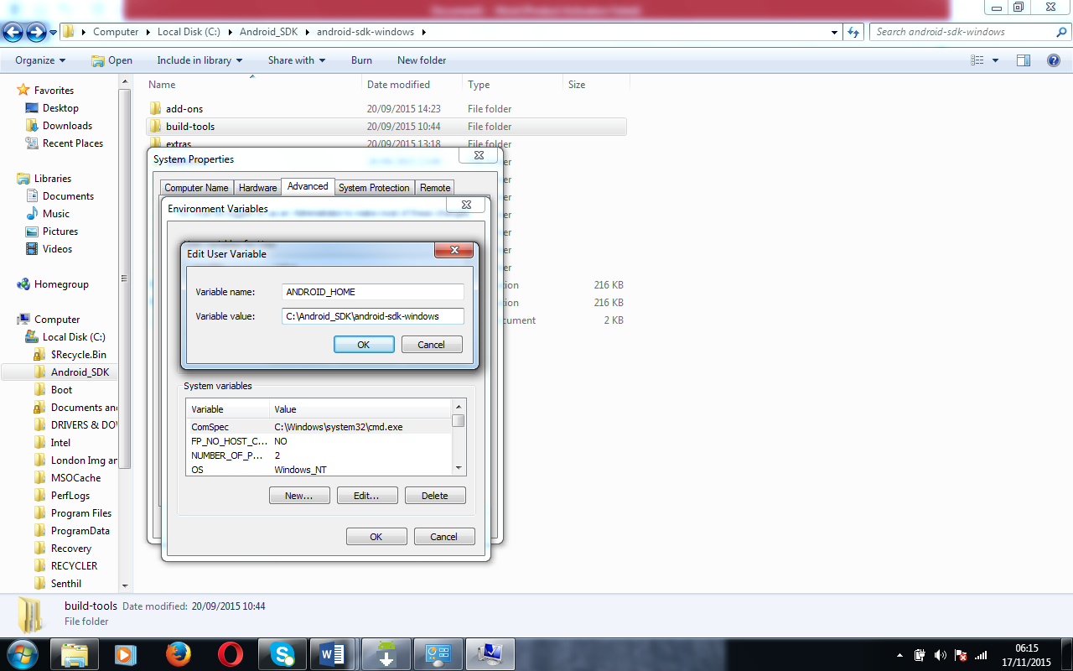

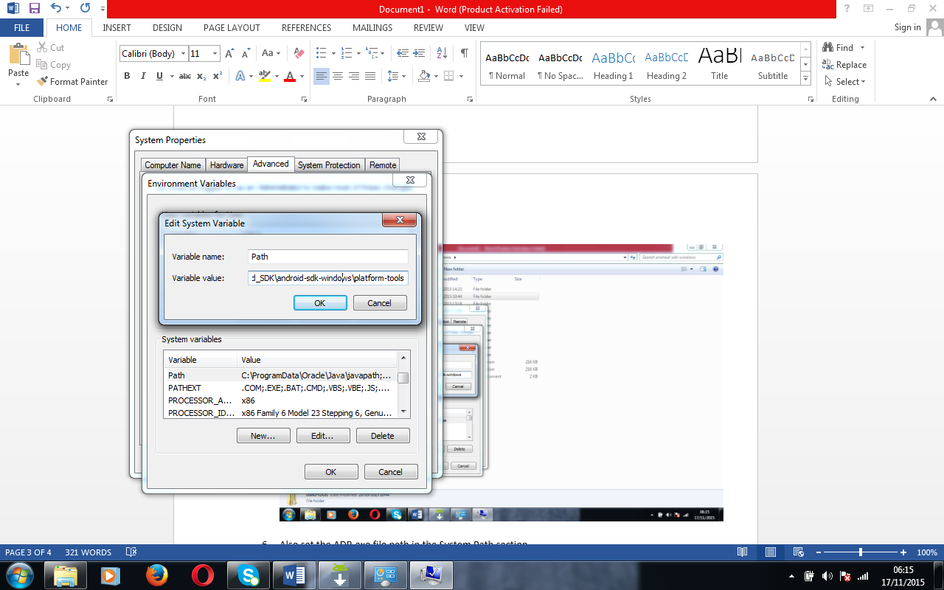

“C:\Android_SDK\android-sdk-windows\platform-tools;”
“C:\Android_SDK\android-sdk-windows;”

- Open Appium server from system start menu (All programs).
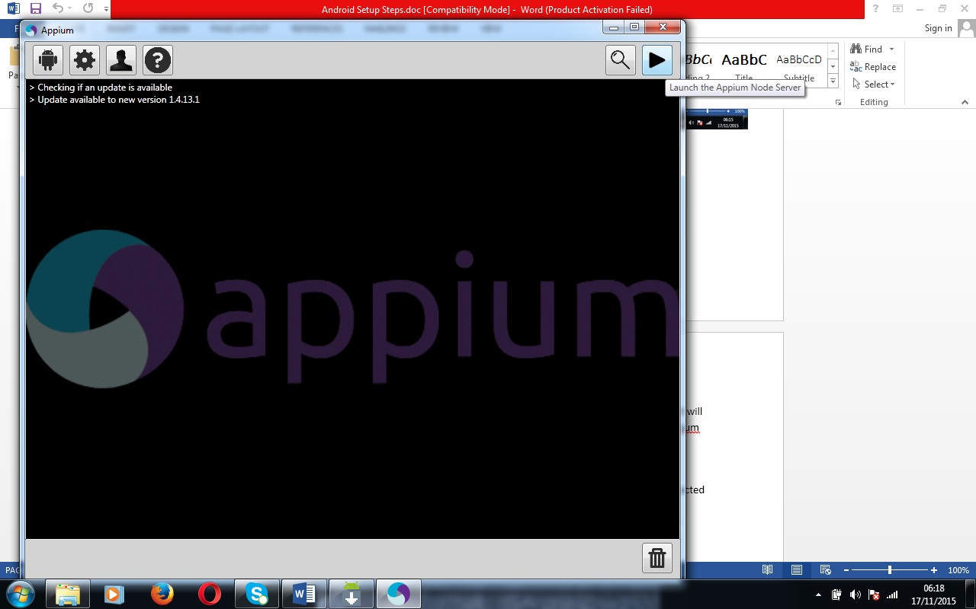
- Once it is launched, click on Start button 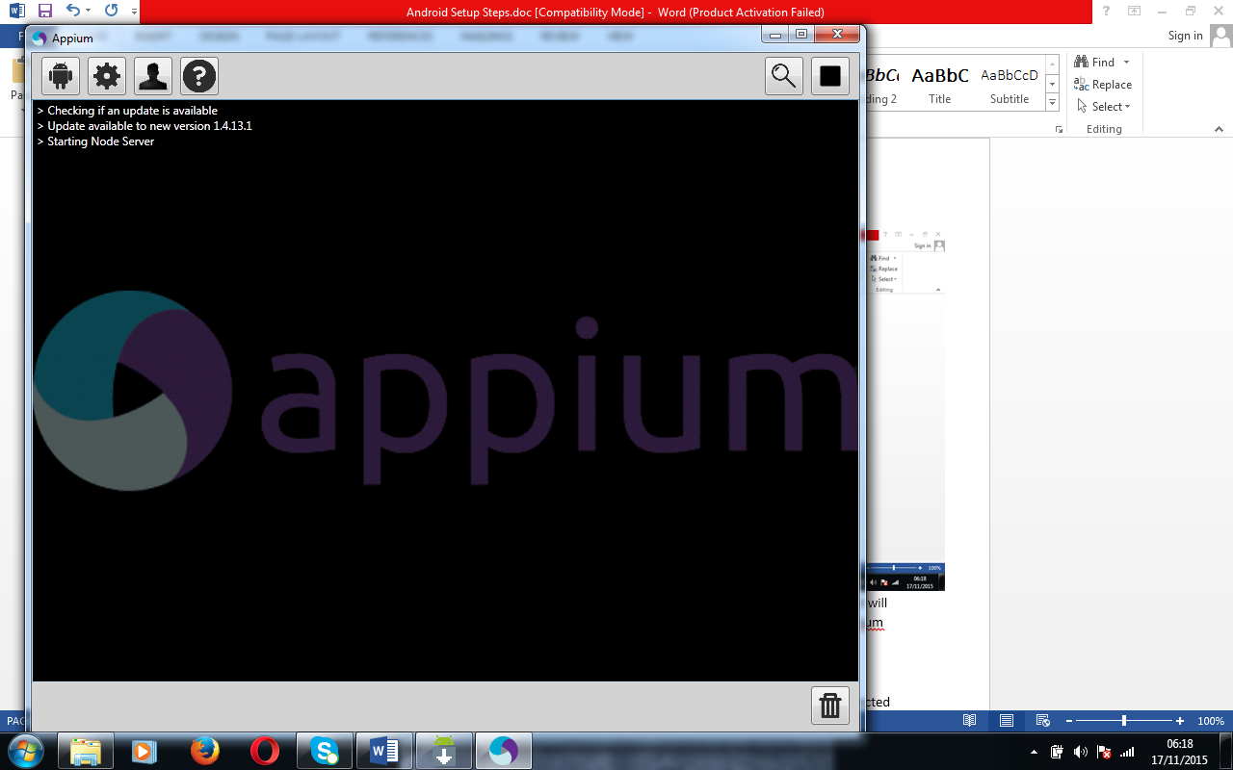
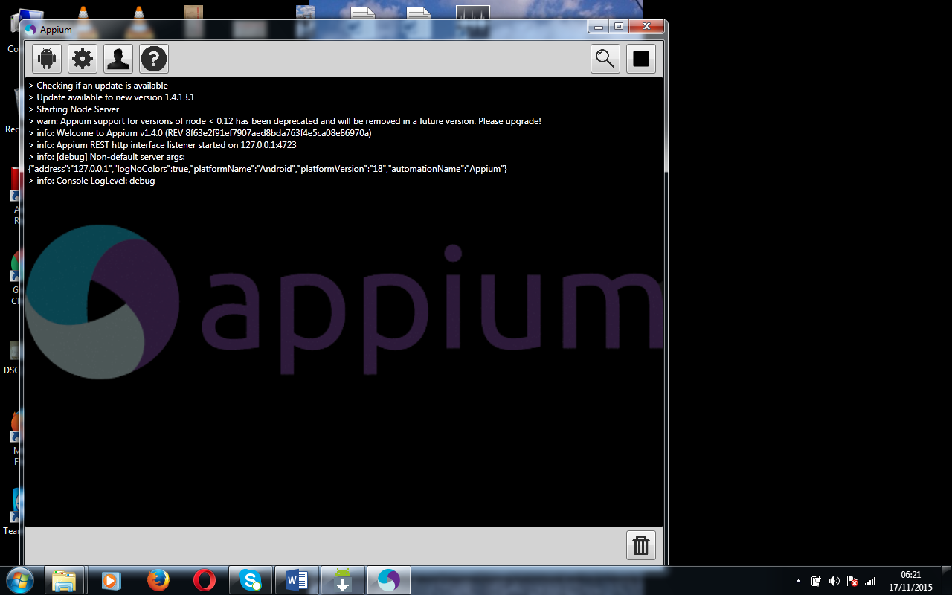

- Then connect the Android devices to your machine using USB cable. Make sure the developer option is enabled.
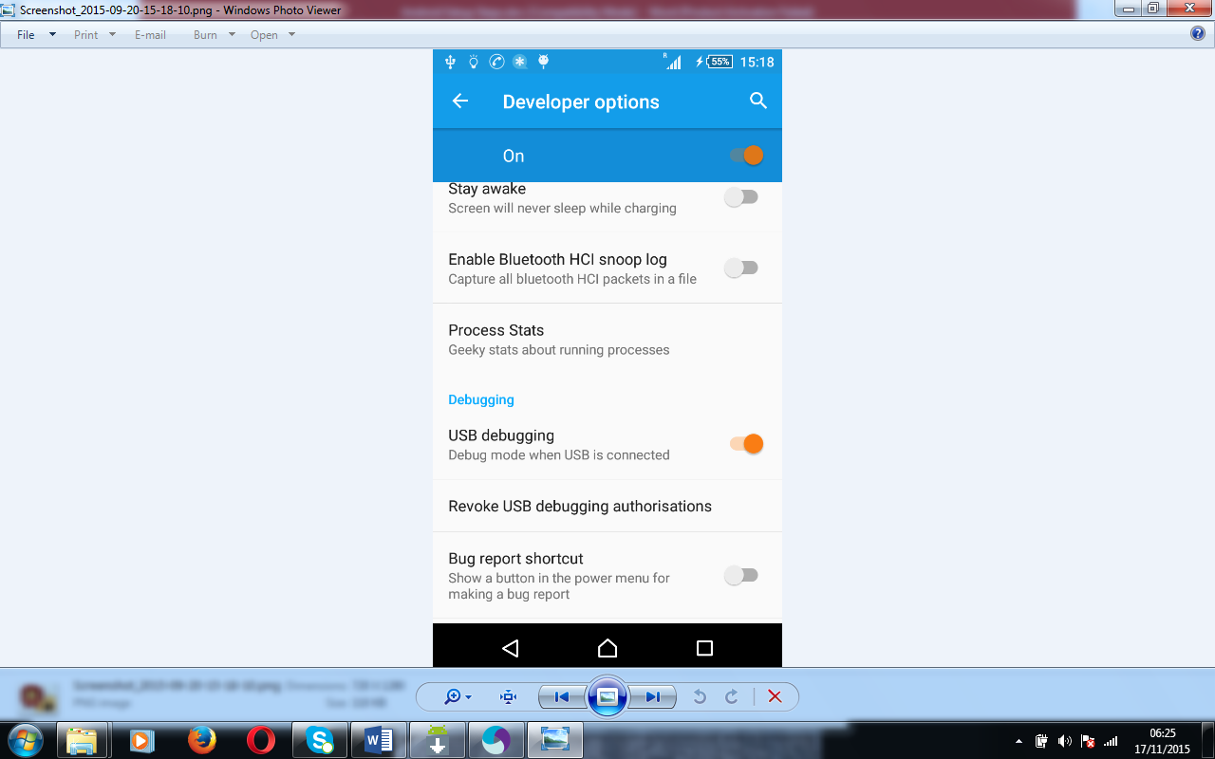

- Install Adb Driver Installer and make sure that Your connected Device status Shows “OK”(Else click Install button to install your connected device driver)

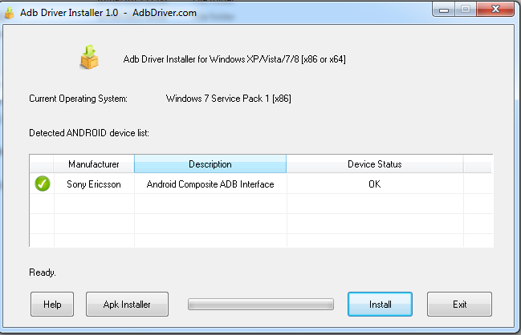
- Go To Command Prompt and try adb devices. It should list the devices which are connected to the machine.
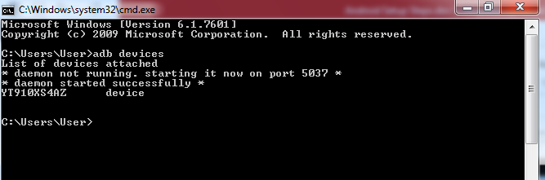

- Find out the below details from the devices
  - Device Name
  - Android Version
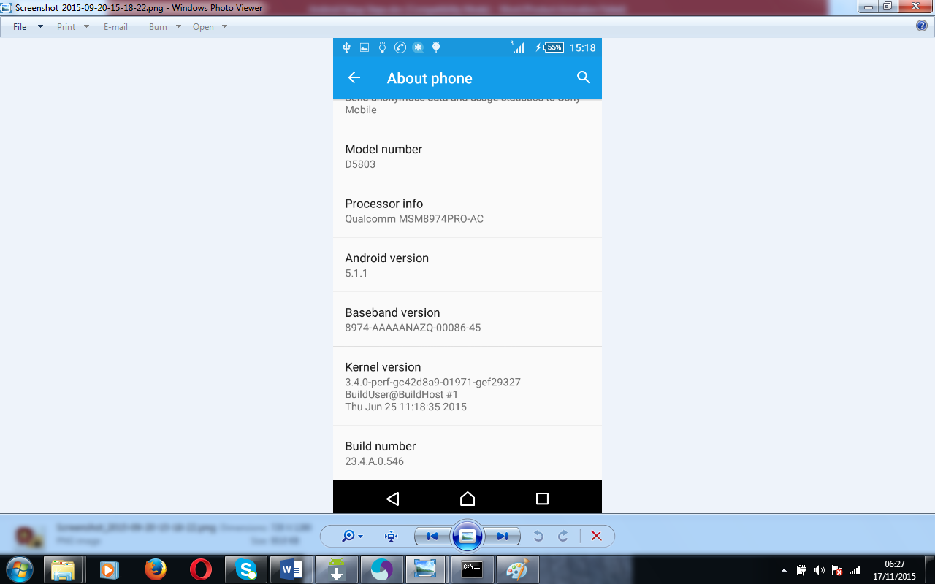
- Find out the below details of the app from the development team or through “Apk Info” Mobile APP
  - appPackage
  - appActivity

- Also find out the below details from the Appium server
  - Server URL (http://127.0.0.1:xxxx/wd/hub)
  - Server port (xxxx → 4723)
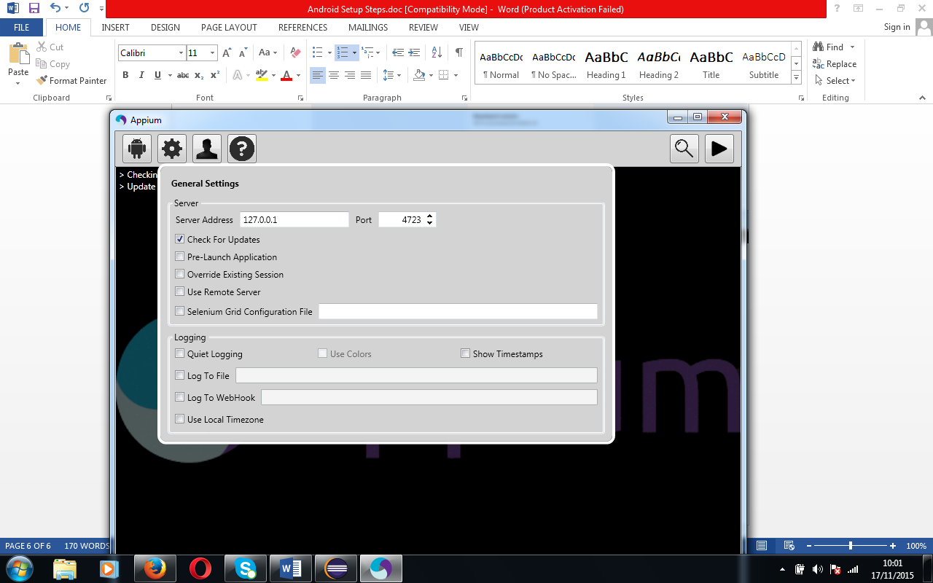
- Add “java-client-3.2.0.jar” in Eclipse
http://mvnrepository.com/artifact/io.appium/java-client/3.2.0

